**Promotional page -** We provide the following resources to help you promote these messages in your church.

1. *JPG image*

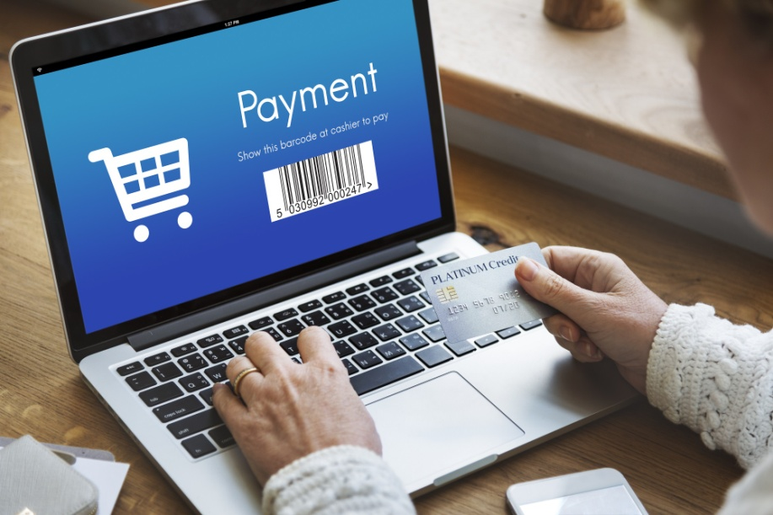

1. *Short announcement*

We make good purchases and bad. Eventually, there is a price to pay. Join us next week as we examine the payment Jesus made to free us from the debt we owed.

1. *Medium announcement*

The only way for us to come to God is for Jesus to exchange His righteousness for our sin. He didn’t want our sin, but He did want us. The reason He had to conduct this transaction is that we traded the treasure God gave us for something as empty and transitory as sin. Join us next week as we examine the poor exchanges humanity made throughout time, and the inexpressible price God paid to get us.

1. *Half-page bulletin insert*

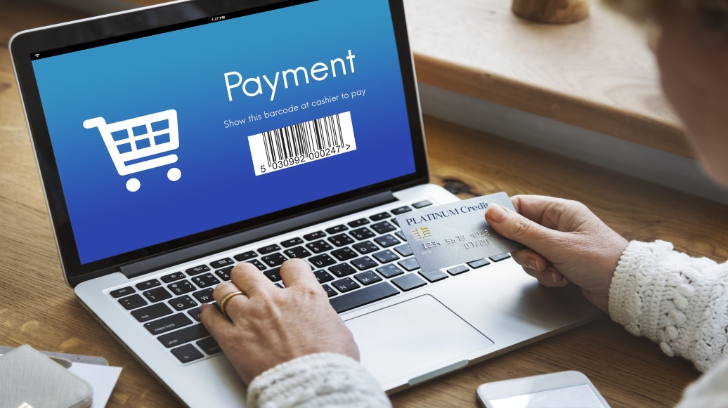

*“He made Him who knew no sin to be sin on our behalf, so that we might become the righteousness of God in Him.”* (2 Cor. 5:21)

You walk into an antique store, and you don’t know what you’ll find. You look for a bargain – something that has far greater value than the price you must pay. Perhaps you’ll find some old comic books, baseball cards, or a toy still in its original packaging. And though you play down its value as you exchange plastic for treasure, when you get out of earshot, you excitedly proclaim, “The guy didn’t know what he had.”

What looks like a treasure to you may seem like trash to someone else. You show off your purchase to a friend or a family member expecting enthusiasm equaling your own. First, they look at the item; then they *examine* you.

How did the angels react when God paid Jesus for us? Join us next week as we explore our terrible choices and the cost God paid to redeem us from our debt.

1. *PowerPoint slides*



